**Experiment: 4-5: Practice DDL Commands (Data Definition Language)**

* **Create table command**
* **Alter table command**
* **Truncate table command**
* **Drop table command**

Command: Create table command



Output:



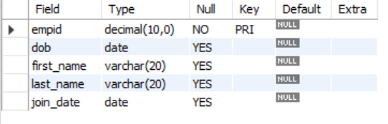

Command: Drop table command

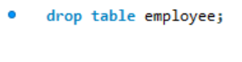

Output:



Command: Alter command

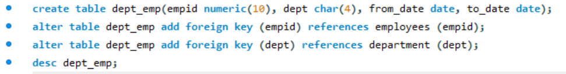

Output:



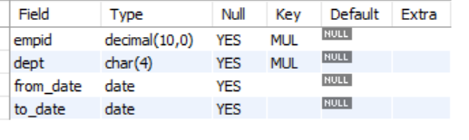

Command: Truncate command



Output:

